UNITED CHURCH OF CHRIST
NTRO UCING E
LOCAL CHURCH PROFILE

October 3, 2018

West Center Congregational Church, UCC
Bronxville, New York

Settled Pastor

New York Conference, Metro Association

VALIDATED: OCTOBER 4, 2018

LOCAL CHURCH PROFILE CONTENTS

Position Posting
- Who Is God Calling Us To Become?
- Who Are We Now?
- Who Is Our Neighbor?
- References
- Consent and Validation

“God is able to provide you with every blessing, so that having all sufficiency in all things at all times,
you may abound in every good work.” (2 Corinthians 9:8)

POSITION POSTING PART 1

LISTING INFORMATION SCOPE OF WORK COMPENSATION & SUPPORT
WHO IS GOD CALLING TO MINISTER WITH US?

Conference: New York Association: Metro
UCC Conference or Association Staff Contact Person
Rev. Dr. Marsha Williams, Associate Conference Minister, New York Conference (845) 500-5082 revwilliams@uccny.org

Summary Ministry Description:
In a short paragraph, reflect on where your church is going and what it might look like when you get there. What do you need to get there? Who are you seeking to join you on this part of your church’s faith journey?

We'd like the church to be a true representation of our community in its diversity in age,
race, household composition, and sexual orientation but common in spiritual goals, love of and service to God. We are looking to draw in the community to engage in fellowship and spiritual growth. Besides being a house of worship, we'd like the church to be integral to the community by providing and promoting not only spiritual programs/studies but also secular programs, events and interest groups that are of true interest to the community. We'd like to update and utilize technology for more effective ministry and outreach, i.e. web streaming, social media and improved audio/visual. Who are we? Our former pastor wrote: “Our West Center is more than a building and a history, our Church is people and programs, working
together, growing together, to build up the Household of God the Community of Faith in service to the world.” Who is our neighbor? Anyone who wants to journey with us or needs us to journey with them. Who is God calling us to become? Better Christians, through prayer, study, meditation and action.

BE THE CHURCH
Protect the environment.
Care for the poor and marginalized.
Forgive often. Reject racism. Strive for justice.
Share earthly and spiritual resources.
Embrace diversity.
Love God.
Enjoy this life.

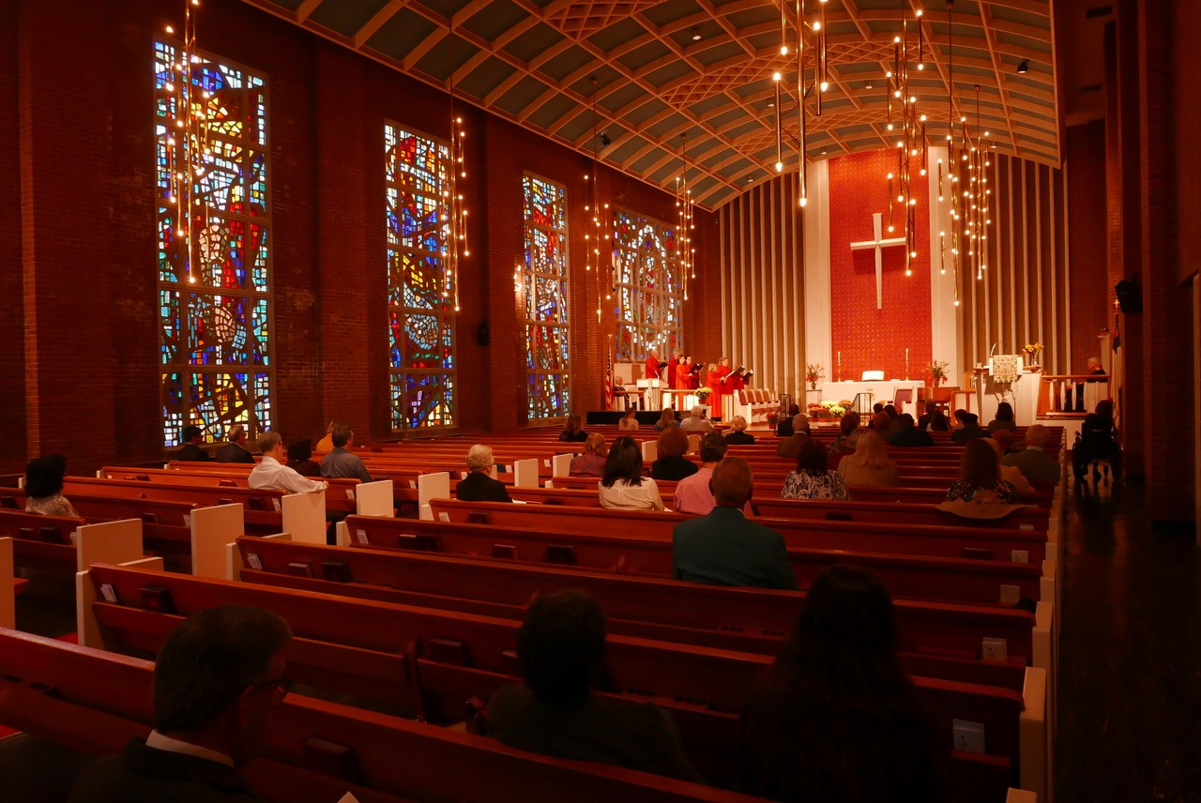

West Center celebrates the retirement of Pastor John Barrett - October 2017

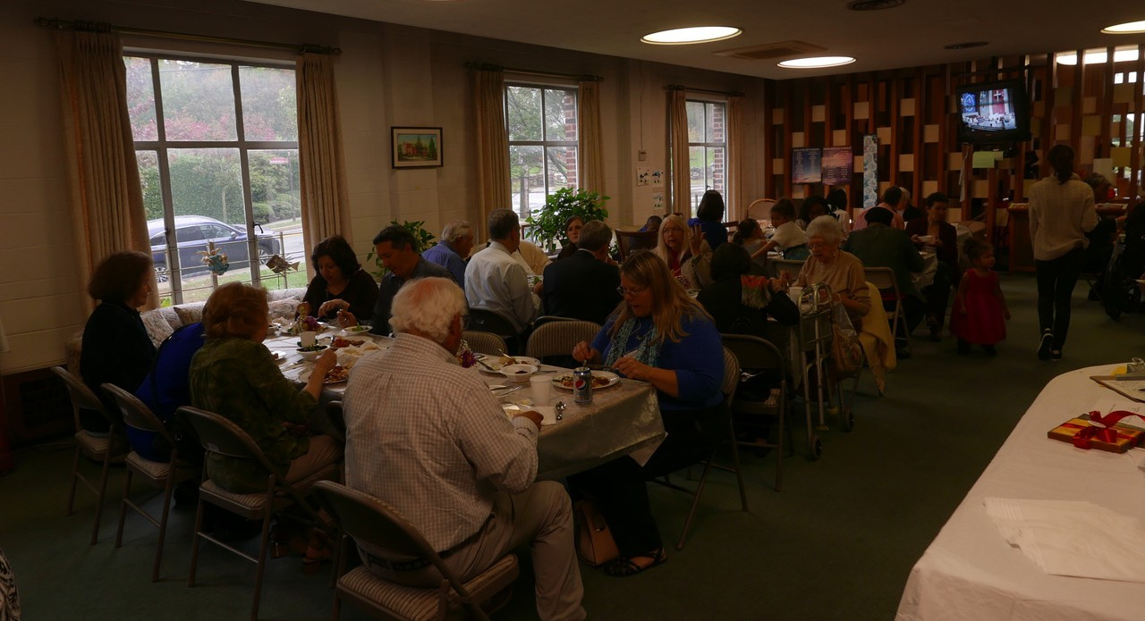

Father’s Day picnic in Bodge Lounge June 2018

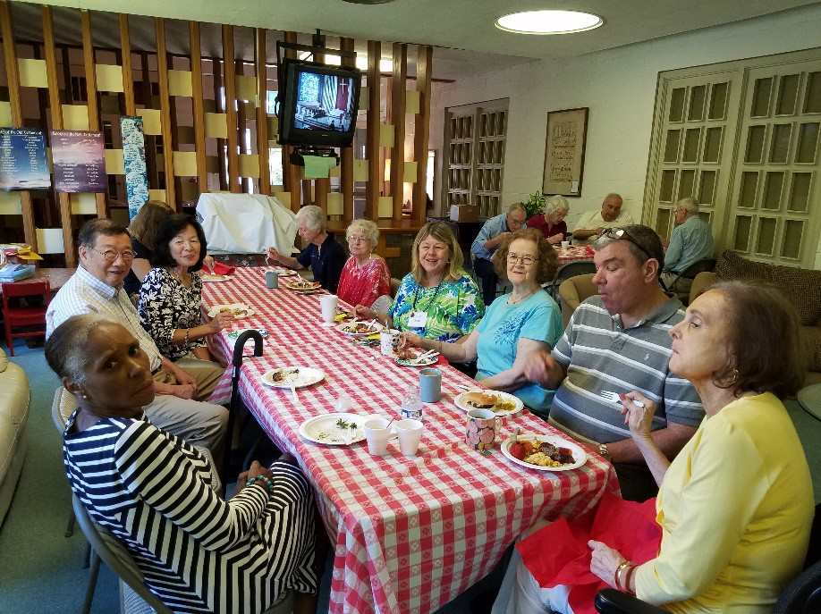

Bodge Lounge, adjacent to our Sanctuary, offers opportunities to get to know each other and to extend a generous welcome at coffee hours and meals. A video area provides the opportunity to watch services held in the Sanctuary as well as special video programs. Air conditioning allows for comfortable summer Worship Services.

To see more pictures of West Center, please go to our website www.westcenterchurch.org
Select About Us then pictures gallery.

------------------------------------------------------------------------------------

What we value about living in our area:

West Center, located in the Bronxville section of the city of Yonkers, provides a lifestyle that is close to a village way of life with a sense of neighborhood yet located in the fourth largest city in the state of New York. Distinctive attributes of the West Center Community include its proximity to New York City, enormous cultural and educational resources, good and plentiful transportation and shopping, and diverse economic and ethnic groups.

Current size of membership: 40

Languages used in ministry (other than English): none

Position Title: Settled

Position Duration:

Settled – a called position intended for longer-term ministry in which the minister moves church membership to the congregation and moves standing to related association
Compensation Level: Full Time at conference guidelines

Does the total support package meet conference compensation guidelines? Yes

SCOPE OF WORK

Scope of work for full time PASTORAL POSITION (40-50 hours weekly / 10-12 units)

- preparation and leadership of Sunday worship including scripture study, crafting of liturgy and bulletin, sermon preparation, guiding and sometimes identifying lay liturgists, coordination of music (creative arts) with musical staff or volunteers, preaching, offering of prayers, etc.
- faith formation and vitality through prayer, Bible study, service, identifying helpful resources and opportunities and helping lay persons take advantage of them
- leadership development by working with people in the church to create ministerial programs
- pastoral care in collaboration with lay people
- community engagement and leading the way for the church to be an ambassador of God’s love
- weddings and funerals for participants in the worshipping community
- strategic planning for current and new directions in governance and ministry
- attend meetings and give leadership as needed to church programs, in collaboration with lay leadership
- participate in wider church activities such as conference and association meetings
- oversees administration functions and performs limited responsibilities such as checking emails, contributing to church newsletter and web site etc.
- faithful financial development and stewardship
- responsibility for supervision of staff
- availability to wider community for funerals, weddings, special worship programs, and as a representative of the church to local organizations
- skilled in consensus building and conflict resolution; counseling, listening and referral
- study and prayer to increase faith and to improve skills to lead, teach, preach better
- energizing and deepening the spiritual connections and faith understandings of others in all they do

Core Competencies: It is expected that that our settled minister would provide Pastoral care, and have excellent preaching and organizational skills.

COMPENSATION AND SUPPORT
Salary Basis: $65,000 to $85,000
Salary, housing allowance and benefits will meet the 2018 Compensation Guidelines for the New York Conference of the United Church of Christ commensurate with candidate’s qualifications and experience.

Benefits:
- Health insurance for candidate
- Worker’s compensation
- Pension
- Social security offset
- Paid sick time
- Paid vacation time
- Parental leave
- Continuing education
- Travel reimbursement for church business

What is the expected living situation for your next minister: Since West Center does not have a manse, a housing allowance is offered. Ideally, we’d like the minister to live nearby but living within commuting distance is an option.

Comment on the residential/commuting expectations for your next minister.
The minister should be close enough to be involved and visible in the community.

State any incentives (e.g. school debt reduction or retention bonus after a certain number of years in position): Not Applicable

Describe peer and professional supports available for ministers in your association/conference:
UCC Metro Association, Westchester UCC Ministers, Bronxville Clergy, NY Conference Communities of Practice

If applicable, describe how your church will adopt part-time adjustments in the pastoral schedule to support a minister’s bi-vocational employment. Not applicable.

WHO IS GOD CALLING TO MINISTER WITH US?

Describe the ministry goals you envision your next minister co-collaborating with the congregation to achieve.
First and foremost we will be discovering who we are as a congregation and in that process discern what it is we feel passionate about. As we go through the process of discovering who God wants us to become we need help in defining those things that we care about. Once we determine that and begin to direct our energies toward helping address problems such as attracting new members, we’ll have a powerful vehicle for growing the congregation. Those choices will be an indication of our priorities and values and reflect how we view ourselves and the world around us. This will inform others who we are in ways that will truly reflect not only who God wants us to become, but what God is calling us to do.

We would look to our pastor in helping us better define our goals and lead us to explore newer ministerial opportunities. We hope to increase exposure with the use of technology and social media. This is an evolving process that can be shaped by us and new members. Drawing new members to our church by asking them to join us and share their ideas for helping the world and for spreading the good news is perhaps the best way to build our church through a foundation of fellowship and mutual values.

We are looking for someone who likes a challenge and who can help the members develop their leadership potential through setting objectives to achieve West Center’s goals. He/she would guide the members in becoming active, engaged and well-organized in church life and show them how to be more professional in their relationships with tenants, event planning and other areas outside the church as well as within. The new minister would work with the congregation in creating a worship service that is meaningful, take an active and enthusiastic role in church activities and participate in community events. Having a minister who is proactive, enthusiastic and willing to share his/her leadership skills with others creates an atmosphere which makes everyone want to serve and be a part of the ministry. We understand that goals and objectives change, and it is expected that both the new minister and congregation would work together to discern what changes may be necessary.

Describe how your vision of the minister you are now seeking will assist the congregation in making an impact beyond its walls.

We seek a minister who would be the public face/spokesperson to express
the welcoming, inclusive, and caring character of West Center both inside and beyond its walls.

Most congregants expressed the urgent need to grow the church by attracting newcomers. The minister should have a real presence in the community by having interest, enthusiasm, and organizational skills to sustain existing events and help develop and execute new outreach goals. Some ideas for new community outreach programs include classes for spiritual growth, seasonal movie nights, participating and/or hosting events relevant to the community, and building the Sunday School (perhaps reaching out to the Montessori School that is located on site). Some of

our on-going events are bible studies, Spring Tag Sale and Christmas Boutique, and various concerts.

Besides attracting new congregants, it is important that the minister engages with new visitors, reaches out to visitors and maintains relationship with members.

Specify language requirements or culturally-specific capacities preferred in a next ministerial leader, and why those matter to the congregation’s sense of calling.
Our Settled Minister should be able to communicate ideas and is inclusive in this communication. Our settled Minister should be an effective preacher/speaker.

Six Areas of excellence from The Marks of Faithful & Effective Authorized Ministry that your next minister will display to further equip the congregation’s ministry:

Building Transformational Leadership Skills

Empowering the church to be faithful to God’s call, reflective of Christ’s mission, and open to the surprises of the Holy Spirit
- Takes initiative in leading God’s mission within our church and community while demonstrating flexibility and a spirit of discernment.
- Motivates others to test and share in a vision and to work toward its realization.

Strategically creating the future of God’s Church
- Exercises effective and adaptive leadership.
- Assesses needs; plans, implements and evaluates ministries to meet identified needs; and continues to improve the future of those ministries.

Encouraging leadership development of self and others through continuing education and lifelong learning.
- Guides and trains members of teams, boards and committees.

Exhibiting a Spiritual Foundation and Ongoing Spiritual Practice Understanding the power of the Holy Spirit at work through the elements of Christian worship to nurture faith.
- Uses silence, language, art, music, ritual, and symbols in crafting meaningful liturgies that respect cultures and peoples and lead to spiritual transformation.
- Connects creativity and the creative arts to an understanding of being made in the image of God the Creator in theology and practice.
- Works effectively with others in preparing worship.

Engaging Sacred Stories and Traditions
Bring to life sacred stories and traditions in worship, proclamation and witness by
- affirming diverse practices in worship, proclamation and witness, and incorporates them into worship planning appropriately

Caring for All Creation

Providing hope and healing to a hurting world
- Prays with and for those in need, and provides spiritual counsel appropriately.
- Plans and leads services of lament healing and hope.
- Show up in solidarity in the midst of struggle.

Participating in Theological Praxis

Practicing theological reflection and engagement as part of one’s sense of ministerial identity.
- Reads and critically evaluates theological texts, informed by a variety of Christian traditions.
Integrating theological reflection in teaching, preaching, and ecclesial and community leadership
- Teaches others to reflect theologically.

Strengthening Inter- and Intra- Personal Assets

Demonstrating excellent communication skills
- Communicates respectfully and appropriately.
- Uses social media creatively and appropriately.
- Engages in “holy listening and speaking” and keeps appropriate confidences.

Respecting the dignity of all God’s people.
- Provides pastoral care as needed to all, regardless of creed, race, gender identity, sexual orientation, physical and mental abilities class, or theological perspective.
- Interacts with others in ways that affirm their own sense of dignity (individually and as members of particular communities) and helps others do the same.
Understanding and ministering to stages of human development across the life span
- Demonstrates a healthy understanding of the dynamics of childhood and adolescence, marriage and singleness parenting and caregiving death and trauma, grief and recovery.

WHO IS GOD CALLING US TO BECOME?
“You shall love the Lord your God with all your heart, and with all your soul, and with all your mind.” (Matthew 22:37 NRSV)

Who is God calling you to become as a congregation?

We want to be a faithful congregation who will be a Church for the community around us as we reflect God’s love for one another. We would like to be a Church that has more participation with the community, so it will allow us to grow.

God is calling us
- to be more than our current self and be a focal point for our community of worship.
- to restore our Church’s relationship with those who have not been attending as well as those who may seek us out.
- to be not just a congregation who is to just survive but grow.
- A warm and caring, active and engaged place of refuge and reflection.

Describe how God is calling you to reach out to address the emerging challenges and opportunities of your community and congregation.

A big challenge in Westchester County is food insecurity. It includes young families, working poor, those on welfare and the elderly, who rely on food pantries to support their grocery needs. West Center has a mission of collecting shelf-stable food and cash donations all year long, which is given to the Yonkers Salvation Army food Pantry. It may be a small part of the great need, but every little bit helps, and the Salvation Army is always grateful for our contributions.

We are in the process of revising our bylaws and making them consistent and relevant for a church of our size. With the help and support of the Interim Minister, a small committee to revise the bylaws has been formed and has begun this work.

For example, describe two experiments your congregation has initiated or engaged in the past year, what were the results and where do you see your next steps?

For many years West Center, under the auspices of its minister, has hired college students from nearby Sarah Lawrence to teach in our Sunday School. A few years ago, 2015, we had two small groups of children which included an early childhood class and an older class who studied for their confirmation. Our current experiment is to use one of the confirmands as our teacher. We find ourselves with no regular attending students. She prepares a lesson each Sunday and is

ready to welcome the occasional students. We would like to develop a plan to re-vitalize our Sunday Schoool and thereby increase attendance and participation.

Under the guidance of our Interim minister, we are slowly changing the worship service to be more meaningful and the results has been received favorably. Changes, based on suggestions from various members, include more music responses, changing the order, and having the congregation participate in the benediction. We are currently working on updating our ability to record services and concerts which currently are only visible in Bodge Lounge.

Has your church had a multi-year strategic plan or vision statement; if so, where do you see that plan/vision taking you?

We are currently involved in creating a strategic multi-year plan. Our vision as a church is to worship the living God, being led by the Holy Spirt, and carry on the work of Jesus Christ with faith and hope.

Our most important immediate and long term goal is church growth - through good ministry, spiritual and outreach programs, community involvement and exposure. We are looking
for guidance from the pastor to assist us in developing a multi-year plan with this goal in mind. Although we have some ideas to promote growth, we need a pastor who is able to
supplement with dynamic thinking and practical approaches. We'd like the pastor to be a conduit between our church and the communities we serve through energetic joyful engagement and active participation.

Our vision is to revitalize the church to promote and sustain growth by providing a variety
of spiritual opportunities for everyone. It will create a safe space for people to come together to explore ideas for church growth, outreach, ministry and fellowship by offering an welcoming and comfortable environment.

WHO ARE WE NOW?
“You shall love your neighbor as yourself.” (Matthew 22:39 NRSV)

CONGREGATIONAL REFLECTIONS

Describe your congregation’s life of faith.

West Center’s life of faith within the church starts with the Sunday and special services that are based on the lectionary readings. It is enhanced with beautiful music from the organist and choir and with sermons that teach us to relate the readings to modern everyday life.
Our Board of World Service collects donations of money, food, supplies and materials that are given to various local organizations such as the Yonkers Salvation Army Food Pantry, Yonkers Animal Shelter, the Veterans Hospital and other organizations. West Center has been honored for its “Five for Five” contributions to UCC designated funds such as One Great Hour of Sharing and Neighbors in Need.

Individual members are active in the community through the Junior League of Bronxville, the League of Women Voters, Boy Scouts, Zonta, the Civil Air Patrol and other volunteer and professional groups. The church reaches out to the community with a Christmas Carol Sing each Advent, fundraising events and concerts.

West Center, originally formed as a church school, has carried on that mission, not only on Sunday mornings but in the usage of the entire church facility. West Center continues this tradition by offering affordable space to a Montessori School, St. Mary’s Syrian Orthodox Christian Church, Sanchin Martial Arts, and other groups. Emphasis has been placed on education, creative arts, counseling and spiritual growth.

For example, what beliefs and commitments are stated in your congregation’s purpose statement or membership vows?
- Believing in Jesus Christ, the interpreter of God, we accept His teachings as the guiding principle of our lives and consecrate ourselves and our Church to their fulfillment. We therefore join and covenant, one with another, to worship, work and serve together that we may express through our Church and our individual lives the life and faith taught by Jesus Christ.

- Worship the living God, being led by the Holy Spirit, to carry on the work of Jesus Christ peacefully, simply, in unity.

How is God most often described in worship liturgy? As a supreme being watching over us, giving us hope and sustaining our beliefs.

In what ways would you describe the Holy Spirit in your midst?

The Holy Spirit becomes visible through the display of love and generosity of our members and friends. The Holy Spirit comforts and consoles us through our worship experiences as well as when we reach out to those having difficult times or joy filled times. The experience of volunteering – members and friends display their love and generosity through their time, talents and treasure.

Describe several strengths or positive qualities of your congregation.
Caring and Generous: We have many talented people who willingly share their gifts from music and the creative arts to organizing, fund raising and gardening. They pitch in when needed, are diligent and hard working

Hospitable and friendly: Bodge Lounge, adjacent to our Sanctuary, offers opportunities to get to know each other and to extend a generous welcome at coffee hours and meals. A video area provides the opportunity to watch services held in the Sanctuary as well as special video programs. Air conditioning allows for comfortable summer Worship Services.
Spiritually driven, forgiving and loyal: We don’t always agree but can come to consensus when needed. Committee meetings begin with prayer which helps center us.

Describe what worship is like when your congregation gathers.

For example, where does worship take place, and what is it based around?

Worship at West Center, planned weekly by the Pastoral Team (Ministers and Music Director/Organist), takes place on Sunday mornings at 11:00am in the Sanctuary. In the Summer months, worship is held in adjacent Bodge Lounge which is air conditioned. The congregation values a style and content of preaching that is biblically based and personally, contemporary, nonrepetitive in making points, anecdotally or humorously illustrated.

The music for the service, carefully selected by our organist/music director, enhances the message of the service. The hymns, selected by consensus of the Pastoral Team, mostly come from the Presbyterian Hymnal, Hymns, Psalms and Spiritual Songs (1990). If appropriate, other sources of hymns and music are used by the Pastoral Team. Paid section leaders augment the beautiful chancel choir.

West Center expects the minister to lead worship services, weddings, and funerals as well as to teach, preach, and administer the sacraments. In addition, the minister will be expected to work with the Board of Deacons to encourage lay participation.

What was a recent baptism like?
My recent Baptism-
Several years ago after being members for just over a year, my daughter Lauren and I were baptized by Rev. John Barrett. It was a very joyful occasion with most of my new friends from the church there. My wife stood beside me and Lauren as Rev. Barrett performed the ceremony and spoke, explaining that this was a sign of outward faith. He asked me if I’d like to say a few words, which I did. I’m not a very good public speaker, but I still remember looking out over the sea of smiling friends and relaxing. I told them all how they made us feel like part of their family and how wonderful our experience at West Center had been. How watching Lauren sitting on the steps leading up to the chancel, along with Ben and Ernest Rice, as John read the lesson of the day was a profound gift, the memory of which I will carry in my heart forever. I thanked them all for welcoming us and giving us a quiet place of shelter from the noise and pressures of our daily responsibilities.

What are some words used to describe good preaching?
Motivating, heartfelt, sincere, anecdotal, humorous, applicable to daily lives within the church and secular life.

Describe the educational program/faith formation vision of your church.

For example, how are young people in leadership?

At this time, we have a graduating high school student who serves as an Acolyte and teaches Sunday School. Her faith formation has led her to continuing to serve as she attends college.

How do people continue to form their faith over a lifetime?

West Center Church believes that education is a life-long process, and so we try to provide a variety of appropriate educational experiences for everyone.

For our Youth…
Parents and children who wish to be together are welcome in the sanctuary, and they also have the option of viewing the service via a closed-circuit television that is available in Bodge Lounge, adjacent to the sanctuary.
The Minister develops and directs the Church School program in coordination with the Board of Christian Education.
Grade school children have classes during the worship hour that are taught by high school and college students hired by the Minister. The current curriculum, Seasons of the Spirit, is lectionary and activity based, and relates to the Scripture and topic of the adult worship celebration.
The current Board is in the process of exploring ways to grow the program. Just a few years ago we had enough students to have an upper and a lower level class. This past year there was just a lower level class.

For Adults….
The adult educational opportunities at West Center are led by the Pastor.
Bible study… A Sunday Bible discussion on the lectionary readings of the day has been offered periodically for several years. Ideas from the sermon and service are included in the discussion. These are truly discussions, rather than presentations. People draw upon their own experience and speak openly about their faith and the Bible, as well as current events.

Name a topic studied or curriculum used recently; what was the impact of this study on those who attended? A recent bible study of John 15:1-8 from the Seasons of the Spirit, led to the greatest commandment – to love one another. An interesting discussion included of how fear blocks the ability to love. Two members of the group, former members of different religious group, told of how loving and accepting they found our church in contrast to their former churches.

Describe how your congregation is organized for ministry and mission.

For example, how are decisions communicated in your church

Information is shared within the various boards at their meetings, at council meetings, via e- blasts, through announcements during the services and as listed on the weekly bulletins, on the website and through The Courier, West Center’s newsletter. We still need to improve our communication and look to our new minister to help with ideas to keep everyone current on what is happening at the church. Also, more effective communication would help us solve potential problems and accomplish goals in a timelier manner. The Bylaws are currently being reviewed and updated to accurately reflect our current governance and enhance communication.

How are teams or committees organized?
There are six boards that cover the different areas of church life – Trustees, Deacons, World Service, Creative Arts and Hospitality. Other committees or teams are formed as necessary by volunteers or by appointment. See Appendix C for chart listing church officers, boards and committees.

Where does your church struggle for vision? We have struggled in determining who we are and where we are needed.

When it comes to decision-making, how many hours are spent in meetings per month? Church meetings usually last 1 to 1 1/2 hours. The Church Council, Trustees and Deacons meet monthly. Other boards meet as necessary.

Think of a time when action had to be taken quickly, for example when a crisis or disaster occurred. How was that accomplished?
A recent snow storm raised the issue of closing the church for reasons of safety. The Pastor was notified by a concerned parishioner and a phone chain was used to disseminate a notice of closing. When more time for notification is available, emails are sent along with posting on the church’s web site.

Can you provide the next minister with a copy of an organization structure, bylaws and/or annual report to further explain the patterns of the church’s activity and governance?
Yes. We are currently restructuring from a governance created for a large church to one appropriate for our size.

- YEAR REPORT: See Appendix D

CONGREGATIONAL DEMOGRAPHICS

Describe those who participate in your church.
 |  | Is this number an estimate? (check if yes)
Number of active members: | 30 | yes
Number of active non-members: | 10 | yes
Total of church participants (sum of  the numbers above): | 40 | yes

Percentage of total participants who have been in the church:
 |  | Is this number an estimate? (check if yes)
More than 10 years: | 38% | yes
Less than 10, more than 5 years: | 45% | yes
Less than 5 years: | 17% | yes

Number of total participants by age:
0-11 | 12-  17 | 18-  24 | 25-  34 | 35-  44 | 45-  54 | 55-  64 | 65-  74 | 75+ | Are these numbers an estimate? (check if  yes)

5 | 1 | 1 |  | 2 | 2 | 12 | 13 | 6 | yes

Percentage of adults in various household types:
 |  | Is this number an estimate? (check if yes)
Single adults under 35: | 2.5 % | yes
Joint household with minors: | 7.5 % | yes
Single adults age 35-65: | 27.5 % | yes
Joint household with no minors: | 15 % | yes
Single adults over 65: | 20 % | yes

Education level of adult participants by percentage:
 |  | Is this number an estimate? (check if yes)
High school: | 100% | yes
College: | 95% | yes
Graduate School: | 10% | yes
Specialty Training: | 15% | yes
Other (please specify):

Percentage of adults in various employment types:
 |  | Is this number an estimate? (check if yes)
Adults who are employed: | 35 % | yes
Adults who are retired: | 42.5 % | yes
Adults who are not fully employed: | ? | yes

Describe the range of occupations of working adults in the congregation:

The range of occupations of working adults include sales, professional specialties, office administrators, managerial executives, trade workers and healthcare professionals.

Describe the mix of ethnic heritages in your congregation, and the overall racial make-up. Most UCC congregations tend to describe themselves as “diverse.” Yet, the vast majority of UCC congregations are mono-cultural. What does diversity mean in your context?

The congregation is predominantly Caucasian of European descent. About 20% of our congregation is a combination of Hispanic, Asian or African Americans.

Has your congregation recently had a conversation about welcoming diversity, or do you plan to hold one on the near future (perhaps using, for example, the Welcoming Diversity Inventory)? Please note the date. Comment after the exercise:

Two years ago, our congregation voted to be Open and Affirming. At our annual meeting held in April 2018, a conversation about welcoming diversity concerned the purchase of a rainbow banner to be hung on an outside wall. All attending were in favor. Most recently, the Pastoral Search Committee reviewed the Welcoming Diversity Inventory and recommends it could be a part of future conversations.

PARTICIPATION AND STAFFING

Complete the following chart. Please leave blank any fields that are not applicable to your congregation.

Ways of Gathering | Estimated number of people involved in attendance | Who plans each of the listed gatherings? (list any and all worship planners, such as various lay leaders, pastors, musicians, other staff)
Adult Groups or Classes | 15 | Pastor
Baptisms (number last year) | 0 | Pastor
Children’s Groups or Classes | up to 6 | Pastor, teacher
Christmas Eve and Easter Worship | 53 | Pastor, Deacons, Music Director
Church-wide Meals | 40 | Congregants, Hospitality Board
Choirs and Music Groups | 4 to 7 | Music Director, Creative Arts Board 4 professional and 3 volunteer singers
Church-based Bible Study | 15 | Pastor
Communion (served how often?) | 15 to 40 | Pastor, Deacons, Once a month
Community Meals | NA
Confirmation (number confirmed last year) | 0
Drama or Dance Program | 0
Funerals (number last year) | 3 | Pastor
Intergenerational Groups | 0
Outdoor Worship | 0
Prayer or Meditation Groups | 0
Public Advocacy Work | 0
Retreats | 0
Theology or Bible Programs in the Community | 0

Weddings (number last year) | 1 | Pastor
Worship (time slot: 11:00 am | 15 - 55 | Pastor, Deacons
Young Adult Groups or Classes | 0
Youth Groups or Classes | 0
Other

List all members or regular participants in your congregation who are ordained, licensed, or commissioned ministers. Indicate those with current United Church of Christ Three-Way Covenants (i.e. serving in a congregation) or Four-Way Covenants (i.e. serving in a ministry beyond a congregation).

Name | Three- or Four- Way Covenant? (3 or 4 or No) | Ministry Setting | Type of Ministry Role | Retired?  (Y or N)
Allan Ross |  |  | Pastor Emeritus | Yes
John Barrett |  |  |  | Yes
Ervin Graves | Interim Minister UCC Chaplain for Metro Assoc. |  |  | No

If one or more previous pastors or retired ministers currently hold membership in the church, describe their role(s) in the life of the congregation: Allan Ross occasionally serves as pulpit supply when needed.

List all current staff, including ministers. Exclude the position you are seeking to fill. Indicate which staff person serves as head of staff.

Staff Position | Head of Staff? | Compensation  (full time, part time, volunteer) | Supervised by | Length of Tenure for  current person in this position
Facilities  Manager |  | Part time, as  needed | Trustees | Many years
Music Director |  | Part time | Creative  Arts Board | 19 years
Interim Minister | Yes | Full time | Church  Council | Less than one year

REFLECTION

Reflection: After reviewing the congregational demographics and activities above, what does this information reflect about your congregation’s overall ministry?

We’re a small congregation looking for variety such as more creative arts in worship or increased spiritual growth opportunities. We’re especially good at providing fellowship coffee hours and meals.

CHURCH FINANCES

Current annual income (dollars used during most recent fiscal year)
Source | Amount
Annual Offerings and Pledged Giving | $ 35,028
Endowment Proceeds (as permitted within spending policy, such as a cap of typically 4.5%-5% on total return) | $ NA
Endowment Draw (beyond what is permitted by spending policy, “drawing down the principal”) | $ 0
Fundraising Events | $ 4,901
Gifts Designated for a Specific Purpose | $ 4,992
Grants | $ 0
Rentals of Church Building | $ 197,141
Rentals of Church Parsonage | $ NA
Support from Related Organizations  (e.g. Women’s Group) | $ 0
Transfers from Special Accounts | $ 0
Other (specify): Bequests and Memorials | $ 7,250
Other (specify): | $
TOTAL | $ 249,313

Current annual expenses (dollars budgeted for most recent fiscal year): $ 226,975
Attached is most recent church budget and annual treasurer’s report as shared publicly with the congregation. See Appendix A and Appendix B.

Considering total budgeted expenses for the year, compare total ministerial support. What is the percentage? 20.7%

Has the church ever failed to pay its financial obligations to a minister of the church? No

Is your church 5-for-5, i.e. does it include each of the following contributions during the church year? (indicate those included during the most recent fiscal year)
_Y_ Our Church’s Wider Mission (OCWM – Basic Support)
_Y_ One Great Hour of Sharing
_Y_ Strengthen the Church
_Y_ Neighbors in Need
_Y_ Christmas Fund

In what way is OCWM (Basic Support) gathered? The support is designated by the Board of World Service.

What is the church’s current indebtedness? $ 0 Total amount of loan debt: $ 0
Reason for debt: N/A
Are capital and other payments current? N/A

If a building program is projected or underway, describe it, including the projected start/end date of the building project and the total project budget. N/A

If the church has had capital campaigns in the last ten years, describe:

Year(s) | Purpose | Goal | Result | Impact
2012-13 | Sanctuary Fund | $ | $8650
2014-15 | Fuel Fund | $ | $8176

If a capital campaign is underway or anticipated, describe: See next question.

Year(s) | Purpose | Goal | Result | Impact
2018 | Heating system repairs | $ to be  determined | $
 |  | $ | $

Describe the prominent mission component(s) involved in the most recent (or current) capital campaign.

As this profile was being written, the Board of Trustees decided to make major repairs to the heating system located in the older part of the church which houses the Bronxville Montessori School and Sanchin Martial Arts. We consider the tenants in our facility as part of our mission to the community. The repairs will be done this summer while the school is on vacation. A capital campaign is being developed. The Trustees will also explore applying for a grant.

Does your church have an endowment? yes
What is the market value of the assets? $354,250
Are funds drawn as needed, regularly, or under certain circumstances? As needed

What is the percentage rate of draw (last year, compared to 5 years ago)? 5 years ago the percentage rate of draw was 12.7 %. Last year was 0%.

Describe draw on endowment, if any, to meet operating budget expenses for the most recent year and the past five years: West Center has greatly decreased its dependency on endowment withdrawals these past 2 years.
2013 | $64,644.46
2014 | $34,000
2015 | $44,000
2016 | $9,200
2017 | $0

At the current rate of draw, how long might the endowment last? N/A

Please comment on the above calculations or estimates: The church has endeavored to stay on budget by cutting costs and increasing income.

Other Assets
Reserves (savings): $ N/A
Investments (other than endowment): $ N/A Does your church have a parsonage? No

Describe all buildings owned by the church:

Church Building and property – West Center’s building, is located on a corner property with a tree lined lawn area and two playgrounds. The church building was built in three stages. The first stage, built in the late 1920’s, includes a three story brick building of about 15,000 square feet which originally housed church school rooms, a worship area, and offices. Stage 2, built in the 1950’s, served as the sanctuary until the Upper Sanctuary (stage 3) was dedicated in 1962.
The end result is one large facility with the Montessori School occupying most of the older part of the building and West Center utilizing the newest areas.

Describe non-owned buildings or space used or rented by the church: N/A

Which spaces are accessible to wheelchairs? (worship space, pulpit, fellowship space, facilities, etc.) Worship space, fellowship space, one bathroom, Library, sacristy

Reflection: After reviewing the church’s finances and assets described above, what does this information reflect about your congregation’s mission and ministry?

For example, when was a time the church made a major budget change?

A major budget change occurred upon receiving the Dorothy Thomson endowment. We were able to:
  - Hire professionals to do much of the work previously done by volunteers. (The most helpful addition was the hiring of a part time facilities manager)
  - Repair and upgrade the church building.

How is the budgeting process done?

The budgeting process begins with the Church Council asking the various boards what funding they will need for the upcoming year. A Finance Committee consisting of the Trustees, representatives from each board, church officers and the minister prepare the budget which is approved by the Church Council and then the congregation at its annual meeting.

What new ministry initiative has your church financed?

We’ve had 2 years of balanced budgets. Our current challenge: how to develop new ministerial initiatives amidst our desire to replenish funds used for our heating system repairs.

HISTORICAL INFORMATION

Name one to three significant happenings in the history of your church that have shaped the identity of your congregation

- Building of the Sanctuary.
- Receiving the Dorothy Thomson endowment
- Hiring a diverse range of ministers.

Add the most important event in the life of your church in the past 10 years.

Celebrating the 100th anniversary of the formation of the Sunday School. Celebrating the 90th anniversary of the formation of the Church.

Describe a specific change your church has managed in the recent past.
The biggest change in the recent past has been the retirement of our long-term pastor and the hiring of an interim minister.

Every church has conflict, some minor, some larger. “Where two or three are gathered, there will be disagreement….” Describe your congregation’s values and practices when it comes to conflict.

Conflict Resolution

While any conflicts are usually resolved among the people involved, there is at least one Member-at-Large who serves on the Church Council. This person represents the entire congregation and is responsible for listening to the concerns of any member or friend and relaying the concern to the council and/or minister. All of this is kept confidential. In addition, the Interim Minister has an open-door policy and is always available to discuss any concerns someone may have and keep it in confidence.

For example, what is an example of a recent conflict and something your congregation learned from it? Describe an occasion when your church experienced conflict without being able to resolve it well. Does your church have policies, protocols or structures for dealing with conflict?)

We are currently reiewing changes to governance while establishing appropriate protocols for dealing with conflict.

Ministerial History (include all previous ministerial staff for the past 30 years)

Staff member’s name | Years of service | UCC Standing (Y/N)
E. Roy Burchell 1968- 1984 | 16 | Y
Robert L. White 1987 – 1993 | 6 | Y
R. Allan Ross 1995 – 2003 | 9 | Y
John M. Barrett 2005 – 2017 | 17 | Y

Comment on what your church has learned about itself and its relationship with persons who provided ministerial leadership:

West Center has had solid relationships with persons providing pastoral leadership. We have had some fairly rocky moments, but we have worked them through, and relationships with pastoral leaders have grown in significant and important ways. None of our pastors left involuntarily.
West Center has had a pastoral relations committee for the past three full time ministers when they began their call. The committees usually met at the request of the minister. In most recent years, periodic assessment of the nature of the work and of the performance of the minister occurs through the minister’s monthly reports to the church council. This allows for ongoing communication and evaluation, as well as the sharing of concerns and accomplishments.

Has any past leader left under pressure or by involuntary termination? No

Has your church been involved in a Situational Support Consultation?

Ask Us We have had only one instance where we needed our area conference minister to help counsel a parishioner who was harassing the minister.

Has a past pastor been the subject of a Fitness Review while at your church? No

WHO IS OUR NEIGHBOR?
“You shall love your neighbor as yourself.” (Matthew 22:39 NRSV)
COMMUNITY VISION
MISSION InSite

COMMUNITY VISION

How do the relationships and activities of your congregation extend outward in service and advocacy? For example, which service activities has your church participated in this past year? Where has the church participated in global connections of care and justice? What is currently transformational in your church’s engagement with neighbors near or far?

West Center has been very good at supporting various ministries financially. Specific relationships and activities are mentioned in this profile’s description of the congregation’s life of faith. Most recently, a small group attended the informational gathering of the Poor People’s Campaign which was shared with the congregation with updates posted on the church’s web site. Our Pastor Emeritus attended the protest march in Albany.

Describe your congregation’s participation in meetings, relationships and activities connecting the wider United Church of Christ (association / conference / national setting).

West Center Participation in the United Church of Christ
q Metro Association spring and fall meetings
q Metro Association workshops
q NY Conference Annual meetings

West Center’s pastors have encouraged members to join them in attending local and state UCC activities. Future pastors would be expected to continue this tradition as well as keep the congregation current in UCC concerns.

Many local churches love to tell the story of what they are doing in the community to transform lives. Some have identified certain aspects of their witness into the wider community using language shared with other UCC congregations. (Find more information as desired at ucc.org.) Check any statements below that apply to your UCC faith community.

Accessible to All (A2A) Just Peace
Creation Justice Global Mission Church
Economic Justice _X_ Open and Affirming (ONA)
Faithful and Welcoming WISE Congregation for Mental Health
_X_ God Is Still Speaking (GISS) Other UCC designations:
Border and Immigrant Justice Designations from other denominations
Inter-cultural/Multi-racial (I’M) None

Reflect on what the above statement(s) mean(s) to your community. Is your congregation interested in working toward any of the above statements of witness in the near future?

Interest was shown in finding out more about these areas. Faithful and Welcoming was suggested.

Describe your congregation’s participation in ecumenical and interfaith activities (with other denominations and religious groups, local and regional).

q Bronxville Village Thanksgiving Worship Service, held at a different church each year.
q Christmas Eve Pageant, held outdoors at the Bronxville Reformed Church. This has been going on for over 100 years and is a beautiful and meaningful tradition. West Center’s minister and lay members have participated through the years. The senior ministers of the village churches monthly luncheon meetings are in transition.
q West Center encourages its pastor to participate in ecumenical and inter faith activities and would appreciate other programs the pastor feels would be of value to the congregation.

If your congregation has a mission statement, how does that mission statement compare to the actual time spent engaging in different activities? Think of the range of activities from time spent gathering, to governance, to time spent going out.

Mission Statement

West Center Church seeks to worship the living God, being led by the Holy Spirit, to carry on the work of Jesus Christ in justice, peace, simplicity and unity.

West Center worships the living God weekly. It carries on the work of Jesus Christ through multiple service projects organized by the Board of World Service including the monthly collections for a food pantry. Hands on work is limited and needs to be increased.

Reflect on the scope of work assigned to your pastor(s). How is their community ministry and their ministry in and on behalf of the wider church accounted for in the congregation’s expectations on their time?

It is expected that the Minister will attend the annual meeting of the UCC NY Conference and the meetings of the UCC Metro Association. Locally, the Minister would occasionally meet with community leaders and neighborhood associations. In the past, the Minister has occasionally met with a group of Bronxville ministers.

MISSION InSite

Comment on your congregation’s MissionInsite report with data for your neighborhood(s) or area.

West Center has reviewed the MissionInsite report and wants to refine the boundaries. The five mile circle used actually extends west across the Hudson River into New Jersey and south into the Bronx. The population listed is for 800,000 people whereas Westchester County where the church is located, has about 400,000.

What trends and opportunities are shown? To be determined.

How do your congregation’s internal demographics compare or contrast to a) the neighborhoods adjacent to your church, and b) other neighborhoods with which your church connects?

The neighborhoods adjacent to the church are upscale suburban indicated by the 10708 zip code which includes a part of Yonkers and the Village of Bronxville. Just under one half of our membership resides in the 10708 area. Others live in Mt. Vernon, New Rochelle, Tuckahoe and several neighborhoods in Yonkers with a variety of economic levels. Our younger families have often moved north (about an hour’s drive) and occasionally come back to visit and/or worship.

How are the demographics of the community currently shaping ministry, or not?
The cost of living in the immediate area of the church is often too high for young families.

What do you hear when you talk to community leaders and ask them what your church is known for? Many know of our church through our long-time affiliation with our tenant the Bronxville Montessori School.

What do new people in the church say when asked what got them involved?
- Attendance at our tag sale
- Greeted by a parishioner
- Religious education for their child

REFERENCES

See Letters of Reference Appendix E

REFERENCE 1
Ms. Cynthia Tether - Friend of West Center Church cindytether@optonline.net

11 DeWitt Avenue
Bronxville, NY 10708

REFERENCE 2
Jean Nelson / Executive Director of the Bronxville Montessori School / Setting
Phone: 914-793-2083 Email: Admissions@BronxvilleMontessori.com

REFERENCE 3
Russell Ashley / A non- member, Church soloist and section leader in the West Center Chancel Choir
rssllashley@aol.com

REFERENCE 4
Jeremy Tressler / a freelance, classical recording engineer, photographer, and artist who has rented space at West Center since the late 1990’s
jer.tressler@gmail.com 914-595-6345

PROMPTS FOR REFERENCES
Describe some areas of strength in this church’s ministry. Describe some areas for improvement in this church’s ministry.
Describe a significant experience you have had of this church’s ministry. Anything else you wish to share.

CLOSING THOUGHTS CLOSING PRAYER STATEMENT OF CONSENT

CONFERENCE/ASSOCIATION VALIDATION

CLOSING PRAYER
The cross, we will take it. The bread, we will break it. The pain, we will bear it.
The joy, we will share it. The Gospel, we will live it. The love, we will give it.
The light, we will cherish it.
The darkness, God shall perish it. Amen.

The Guest House
JELALUDDIN RUMI, TRANSLATION BY COLEMAN BARKS

This being human is a guest house. Every morning a new arrival.

A joy, a depression, a meanness, some momentary awareness comes as an unexpected visitor.

Welcome and entertain them all! Even if they are a crowd of sorrows, who violently sweep your house empty of its furniture,
still, treat each guest honorably.
He may be clearing you out for some new delight.

The dark thought, the shame, the malice.
meet them at the door laughing and invite them in.

Be grateful for whatever comes. because each has been sent
as a guide from beyond.
LOCAL CHURCH PROFILE – 2017 PAGE 32

STATEMENT OF CONSENT

The covenantal relationship between a church and those called by that church to serve as pastors and teachers and in other ministerial positions is strengthened when vital information is openly shared by covenantal partners. To that end, we attest that, to the best of our abilities, we have provided information in this profile that accurately represents our church. We have not knowingly withheld any information that would be helpful to candidates.
As the committee charged with the responsibility for identifying and recommending suitable new minister for our church, we have been authorized to share the information herein with potential candidates. We understand that a candidate may wish to secure further knowledge, information, and opinions about our church. We encourage a candidate to do so, recognizing that an open exchange of relevant information builds the foundation for continuing and healthy relationships between calling bodies and persons seeking a ministry position.

  - Which individuals and groups in the church contributed to the contents of this Local Church Profile? (for example, church council or consistory, transition team, etc.) The church profile was written by the Pastoral Search Committee with input from the Church Council, the Church Treasurer, and the Congregation.

  - Additional comments for interpreting the profile:

Signed:
September 17, 2018
Hayley Moreno Chow Co Chair of the Pastoral Search Committee Jo-Ann N. Dierks Co Chair of the Pastoral Search Committee

VALIDATION BY CONFERENCE/ASSOCIATION

The congregation is currently in good standing with the association / conference named.
Staff Comment: YES

To the best of my knowledge, ministerial history information is complete.
Staff Comment: YES

To the best of my knowledge, available church financial information is presented thoroughly.
Staff Comment: YES

My signature below attests to the above three items.

Signature: Rev. Dr. Marsha Williams Name / Title: Associate Conference Minister Email: revwilliams@uccny.org
Phone: 845-500-5082
Date: 10/3/18

Appendix A
WEST CENTER CHURCH ANNUAL TREASURER'S REPORT - 2017

 | INCOME | 2017  BUDGET | 2017  ACTUAL | ACTUAL as% of BUDGET
General Giving |  | 42,000.00 | 35,028.92 | 83.4%
Building
Montessori School - contribution |  | 115,788.00 | 116,946.00 | 101.0%
- electric |  | 8,000.00 | 6,796.89 | 85.0%
Jeremy Tressler - contribution |  | 9,600.00 | 9,600.00 | 100.0%
- electric |  | 300.00 | 905.84 | 301.9%
St. Mary's Jacobite S.O. Church |  | 20,400.00 | 20,400.00 | 100.0%
- cleaning |  | 2,400.00 | 2,400.00 | 100.0%
Sanchin Martial Arts |  | 20,820.00 | 20,820.00 | 100.0%
Brooke Johnson |  | 7,800.00 | 7,800.00 | 100.0%
David Nichols |  | 4,200.00 | 5,250.00 | 125.0%
Other Building Income |  | 5,000.00 | 6,222.50 | 124.5%
 |  | 194,308.00 | 197,141.23 | 101.5%
Designated Contributions |  | 5,000.00 | 4,992.00 | 99.8%
Memorials and Bequests |  | 800.00 | 7,250.00 | 906.3%
Fund Raisers |  | 6,000.00 | 4,901.10 | 81.7%
Total Income |  | 248,108.00 | 249,313.25 | 100.5%
Transfers from Endowment Fund |  | 8,836.44
Total Income and Transfers |  | 256,944.44 | 249,313.25 | 97.0%
 | EXPENSES
Staff  Sr. Minister's Salary* |  | 83,000.00 | 68,215.89 | 82.2%
Music Director's Salary** |  | 34,347.00 | 34,347.00 | 100.0%
Facility Manager's Salary** |  | 22,000.00 | 23,241.59 | 105.6%
Gifts |  | 900.00 | 1,556.00 | 172.9%
Unemployment Insurance Tax |  | 600.00 | 425.48 | 70.9%
Conferences and Travel · |  | 120.00
Workers' Compensation Insurance |  | 2,500.00 | 2,213.00 | 88.5%
Pastoral Discretionary Fund |  | 100.00 | 50.00 | 50.0%
Legal Counsel Fee |  | 31.00 | 31.00 | 100.0%
Umbrella Liability Policy |  | 300.00 | 300.00 | 100.0%
 |  | 143,898.00 | 130,379.96 | 90.6%
* Includes Salary, Housing and Pension
** Includes Salary and FICA

ANNUAL TREASURER'S REPORT - 2017 ACTUAL
 | 20,800.00 | 12,716.08 | 61.1%
Missions/Special Offerings | 2,700.00 | 2,770.00 | 102.6%
Boards
Deacons | 1,700.00 | 3,605.94 | 212.1%
Creative Arts / Music | 15,000.00 | 13,700.00 | 91.3%
Christian Education | 2,000.00 | 1,845.57 | 92.3%
World Service | 1,800.00 | 1,800.00 | 100.0%
Hospitality | 100.00 | 49.99 | 50.0%
 | 20,600.00 | 21,001.50 | 101.9%

as% of
BUDGET ACTUAL BUDGET

EXPENSES - cont.

Office | Telephone and Internet | 1,900.00 | 1,852.62 | 97.5%
 | Office Supplies and Computer Repair | 2,500.00 | 1,752.84 | 70.1%
 | Petty Cash | 400.00 | (-83.00)
 | Postage | 500.00 | 294.00 | 58.8%
 |  | 5,300.00 | 3,816.46 | 72.0%
Building
 | Cleaning including Carpet Cleaning | 2,000.00 | 1,898.00 | 94.9%
 | Heat | 22,000.00 | 20,091.24 | 91.3%
 | Water | 2,000.00 | 2,027.03 | 101.4%
 | Con Edison | 12,000.00 | 10,438.08 | 87.0%
 | Snow Removal | 2,500.00
 | Building Supplies | 1,800.00 | 2,088.76 | 116.0%
 | Property Insurance | 13,000.00 | 10,794.50 | 83.0%
 | County Taxes | 2,236.52 | 2,236.52 | 100.0%
 | Alarm System Monitoring and Permit | 2,609.92 | 2,609.92 | 100.0%
 | Grounds | 2,000.00 | 1,770.00 | 88.5%
 | City Frontage Tax |  | 189.00
 | Help to Hang Banner |  | 100.00
Building | Repairs and Improvements | 62,146.44 | 54,243.05 | 87.3%
 | Heating System Repairs | 6,000.00 | 4,079.50 | 68.0%
 | Electrical Repairs | 2,000.00 | 186.49 | 9.3%
 | Plumbing Repairs and Window Wells | 800.00 | 655.00 | 81.9%
 | Roof and Gutter Repairs and Cleaning | 7,000.00 | 215.00 | 3.1%
 | Painting | 500.00
 | Window Repair/Replacement | 200.00 | 124.69 | 62.3%
 | Fire Extinguisher Service | 300.00 | 587.00 | 195.7%
 | Front Door Closer | 2,300.00 | 1,500.00 | 65.2%
 | Other - Strip and Wax Floors Leath Hall |  | 1,300.0
- Oil Tank Room Work |  |  | 2,340.00
- Toilet Paper Holders |  |  | 97.36[
- Intercom System |  | 1,700.00 | 245.00 | 315.8%
- New Exit Signs |  |  | 51.04
- Rug Replacement  - Water Heater Replacement |  |  | 575.00  760.00

ANNUAL TREASURER'S REPORT-2017

Other

Pulpit Committee 1,000.00
Flowers and Christmas Decorations 400.00 15.99 4.0%
Boutique Expenses 100.00
Pastoral Search Committee 12.50
John Barrett's Retirement Party 520.00
John Barrett's Retirement Gift 1,500.00
1,500.00 2,048.49 136.6%

Total Expenses
256,944.44 226,975.54 88.3%

Appendix B

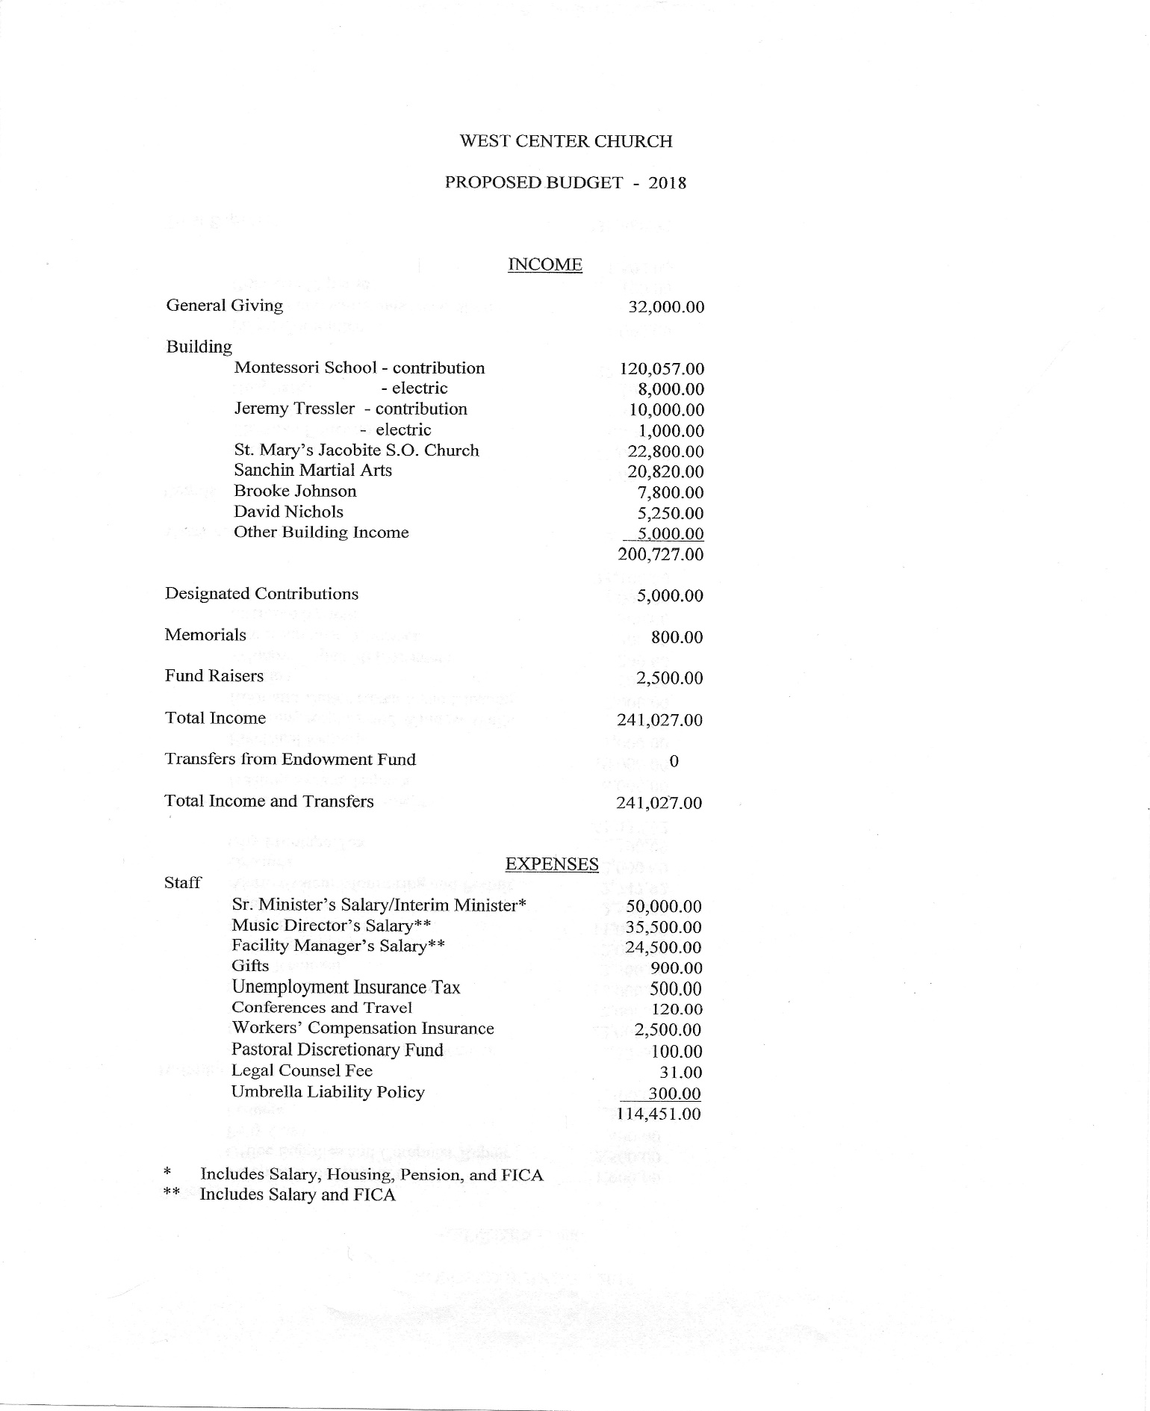

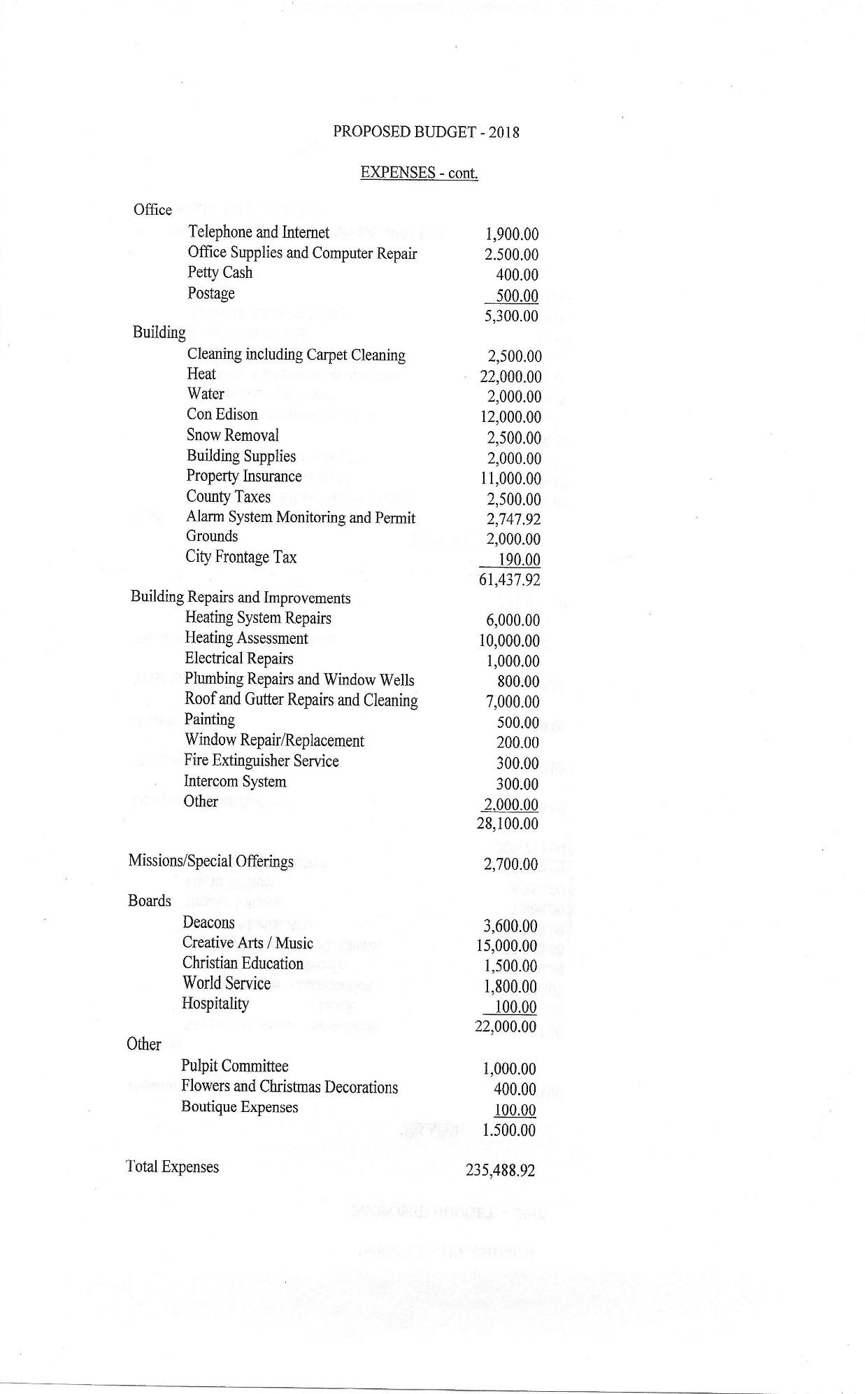

Appendix C

Proposed Officers and Board Members 2018-2019 Boards and Committees, Elected and Voluntary
Group | Members | Function/Responsibilities | Meetings
Church Council | Officers, Interim Minister, Music Director, Board  Chairs | Main Governing body  Sets policy and strategic plan for the church | Five times a year or mor frequently if needed
Church Officers |  | Elected Positions
Moderator | Susan Reisinger | Presides over council and congregational meetings  Prepares agendas and follows vision and goals of church
Clerk | Georgia LaBlanc | Takes minutes at all meetings;  maintains files of all church records
Treasurer | Jeanette Johnson | Tracks and balances all accounts, keeps all financial records; receives and disperses funds; provides monthly reports for  meetings and annual report for annual meeting
Financial Secretary | Rose Lou | Records & deposits funds received  Tracks all congregational donations & provides reports of  all money received to Treasurer.
Member at Large (should have  two) | Jeanne Stano Open | Provides input at meetings on behalf of the congregation
Church Boards | Names in bold ar the chairs | e Elected Positions
Board of Trustees | Tom Riggs (Co- chair)  Peggy Looney (Sec.)  Georgia LaBlanc Jeanne Stano | Responsible for all financial, legal business and personnel matters Oversees upkeep of building and grounds and use of church facilities by outside groups and organizations | Monthly or more frequently  if needed
Deacons | Charles Mitchell Bambi Mitchell Charlotte Johnson Teresa Rosado | Responsible for all pastoral and worship activities including communion, assigning ushers and greeters and preparing communion trays, Assists minister in spiritual interests of the church | Four or five times per ye as needed

e

Hospitality | Georgia LaBlanc Tom Riggs Jeanette Johnson Paul Collarile | In general, the committee promotes fellowship within the church and assists deacons with membership and caring for others.  Organizes fellowship hours and special meals, orders fresh flowers and plants for selected services, maintains indoor plants and other duties as needed. | As needed
Christian Education | Charlotte Johnso Jo-Ann Dierks Rose Lou  Bambi Mitchell | n General direction over all educational activities for children and adults including but not limited to Sunday School, bible study and discussion and other educational endeavors. | As needed
World Service | Jeanette Johnson Jeanne Stano Charlotte Johnson Scott Johnson  Rick Macerata Peggy Looney Rose Lou Teresa Rosado  Peter Rosado | Promotes outreach interest beyond local congregation. Disperse budgeted funds to various charities.  Develop, plan and implement other forms of mission and outreach such as food collection and delivery and other special  collections and projects. | Once or twice per year
Creative Arts | Jo-Ann Dierks Susie Reisinger Rose Lou | In charge of music and other arts activities for both worship services and special events. Plan and implement special arts activities such as concerts, art  exhibits, etc. Provide support to the Music Director. | Twice a year or more as needed
Committees |  | Not Elected
Finance Committee (Committee of Trustees) | Jeanette Johnson Peggy Looney Georgia LaBlanc Rose Lou  Susie Reisinger | Plan budget  Manage endowment and research ways to receive better returns on investment | Yearly or more as neede
Financial Assistant (Committee of Trustees) | Georgia LaBlanc Peggy Looney | Assist Financial Secretary in tallying contributions | As needed
Property Committee (Committee of Trustees) | Tom Riggs Bambi Mitchell Adam Coccoccia | Responsible for maintenance of church building and grounds and supervises work of church custodian.
Grounds Committee (Committee of Trustees) | Susie Reisinger Rose Lou | Outdoor landscaping and general condition of church grounds | Seasonally
House Committee (Committee of Trustees) | Georgia LaBlanc Jeanette Johnson Susie Reisinger Adam Cococcia | Oversees the use of the church facilities by outside groups. With consent of Trustees, establishes conditions for the use of church,  subject to consultation with ministry | As needed

Prudential Committee (Committee of Trustees) | Paul Collarile Others as needed | Advises Trustees in all legal and financial matters. Responsible for complete insurance program for church, wise investment of church funds sees that church gets full tax  exemption credit and other matters. | As needed
Memorial Committee (Committee of Trustees) | Jeanette Johnson | Establishes and administers program for bequests and endowments,  develops and utilizes memorial gifts | As needed

Note: The Finance, House & Grounds, Prudential and Memorial Committees and Financial Assistants are part of the Board of Trustees. Its members do not have to be Trustees and their participation is voluntary.

Committees Not Elected

Group | Members | Function/Responsibilities | Meetings
Publicist/Director of Public Relations | Susie Reisinger | Publicize and promote all services and special events; devise PR plan for promoting the church within the  community
Pastoral Relations Committee | TO BE FORMED WHEN NEW MINISTER IS CALLED &/OR AT THE REQUEST OF THE INTERIM  MINISTER | Liaison between minister and congregation | Quarterly or as needed
Other Positions Needed |  | Volunteers Needed
Website/New Media Committee | Jo-Ann Dierks Joy DeBellis | Design and update website on weekly basis. Research and select redesign and upgrade of website.  Possibly research and select new equipment for church use. Send eblasts as requested by minister  and moderator/publicist. | As needed
THE COURIER | Susie Reisinger | Edit, write, solicit articles/news, organize layout, publish & distribute West Center’s bi-  monthly newsletter
Archivists - Artwork, Photos, Videos and Displays For Church Archives  (Need people to work on this committee) | Rose Lou  June Nickerson Amanda Moore | Maintain art/photo/video archives both hard copies and online.  Take photos & videos, provide artwork & make displays of various church events & milestones.  Maintain files. | As needed
Catherine Cleverdon Memorial Library | Amanda Moore | Updates and maintains library, encourages members and friends to borrow and read the books available; Goal is to make it a working library again. | As needed

Church officers include Moderator, Clerk, Treasurer, Financial Secretaries and Members-at-Large

Appendix D

11-YEAR REPORT: Not available
Appendix E Letters of Reference

July 8, 2018

To me, West Center Church represents all a church should be. Its members are the friendliest and most gracious that anyone could hope for or even imagine. They are both talented and humble, and the world is a better
place because of them.

Always willing to help and encourage each other, the members of West Center Church embody Christ’s teachings on Earth. Although small in number, they share their blessings with those in need through many mission programs, including One Great Hour of Sharing, Neighbors in Need, and the Salvation Army, to name just a few, as well as donating calendars and magazines for the elderly at local assisted-living facilities and school supplies for children of low-income families in
the local community. These many benevolent focus areas throughout the year keep the members’ hearts light and filled with joy that they then transmit to others in their midst.

The sermons at West Center Church are scriptural and relevant to today, inspiring the congregation to do God’s will from one Sunday to the next.
In addition, the music is motivating and professional, and the stained-glass windows in the sanctuary are rapturously beautiful and meaningful.

It’s indeed a privilege and a pleasure to attend worship services at West Center Church. If you come to visit, you will want to stay. Like a magnet attracts metal filings, the allure of West Center Church will capture your heart, and you will gravitate toward it as your spiritual home.
Sincerely, Cynthia Tether
Friend of West Center Church

11 DeWitt Avenue
Bronxville, NY 10708
cindytether@optonline.net

BRONXVILLE MONTESSORI SCHOOL
101 Pondfield Road West
Bronxville, New York 10708 Phone: 914-793-2083 Fax: 914-793-2360
Email: Admissions@BronxvilleMontessori.com www.BronxvilleMontessori.com

September 17, 2018

To Whom It May Concern,

I have been a part of West Center Congregational Church since 1974. I have watched many ministers with their different styles as pastors in this church. All have been different, but all have been committed, caring shepherds of their flock.

The congregation has changed much in the past 44 years with some sad departures and many caring additions. Always, though, the concern for others and solid Christian values have been a reliable part of all the pastors and members.

As a long-time renter of the older section of this church I have seen many challenges that have been met by West Center Congregational Church. Decisions are made by the council with care and deliberation. I am sure that the elders will continue to do so.

Any minister who is chosen will be welcomed by a dedicated group of congregants. Although small, as many church groups are today, they are a committed, warm group of men and women who genuinely care about their church community.

Change is inevitable, but this group of people meet it with grace and humor. I am sure anyone who joins West Center Congregational Church will be happy to be part of it.

Sincerely,

Jean Nelson
Founder and Executive Directress Bronxville Montessori School

To whom it may concern,

West Center Church has been my church home for the past 15 years. As a soloist and choir member, music has always been an important part of the worship service for me. Our organist, Arnold Ostlund, is a first rate musician who always gives the choir and soloists great music to lift the spirits of the congregation. The excellent acoustics in our sanctuary make the music all the more satisfying. As a songwriter/guitarist, I truly enjoy the opportunity to share my music with the congregation.

One final but very important bonus: the food and conviviality after the service is "par excellence"!

Sincerely,
Russ Ashley rssllashley@aol.com

September 17, 2018
To Whom It May Concern,

I am a freelance, classical recording engineer, photographer, and artist who has rented space at WCC (West Center Church) for my work since the late 1990’s when I began my career in my twenties. During this time, I have come to know the church through its operations, the staff, and a handful of key members. I have also witnessed two ministers fulfill their tenure and ultimate retirement.

WCC functions as a democracy with each member of its respective voting bodies carrying one vote. Effective direction and decisive action can be hard won if the voting members lack a deep knowledge and / or a shared understanding of the issues they are called upon to debate. In this regard, WCC can be as clumsy and inefficient as any true democracy, and it is in this space where the spirited leadership of a passionate and involved minister can be especially helpful.
The members take their responsibilities to the church very seriously and there is a deep level of commitment and love for the institution. Although the present congregation is small and mostly 50+ years of age, you will find a very diverse set of perspectives among these people as they are bound together not by ideology, but by a sense of community and a shared love for an accepting and all encompassing god.

WCC would greatly benefit from a leader and visionary who is able to integrate its doctrine into the experience and challenges of contemporary life. Furthermore, this leader should be an an engaging, community loving, family oriented, people person who is as fluent and comfortable with the youth culture as with those of us who are in the second half of our lives. I feel it’s especially important for the ministry to stay connected with the changing needs and perspectives of the community.

WCC dwells within a neighborhood that has four large and thriving churches, and it is with such examples in mind, that I see no credible reason why WCC should not also increase its audience with the community. Although the facility resides in the highly affluent East end of Yonkers and Bronxville, it is within a few miles of the more economically diverse sections of Mount Vernon and greater Yonkers.

The facility has been well preserved through the generous support of its core parishioners and offers a visually and acoustically inspiring atmosphere in which to contemplate and worship.

Sincerely, Jeremy Tressler jer.tressler@gmail.com

914-595-6345
www.dreamflower.us www.photograpme.us www.jeremytressler.com

This document is created through support to Our Church’s Wider Mission (OCWM) and is only possible through the covenantal relationships of all settings of the United Church of Christ.

“Jesus answered them, ‘Have faith in God!’” – Mark 11:22

